**AR (Bank Deposit Book – Cheques & Cash)**

* Separate 3 sheets (with blue fold behind)
* Fill Out:
  + Deposit date & Initials
  + Customer Name (Who Cheque is From)
  + Cheque #
  + Amount of Cheque ($)
* Repeat for multiple cheques
* Double Check Total deposit calculation for multiple cheques
* Place Cheques in Chequebook & have ready for Phil to take to bank for deposit  
  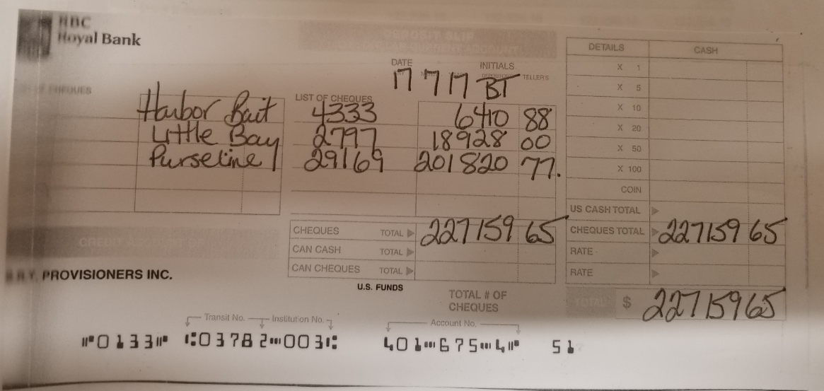

***NOTE – Final step in GL-deposit needs to transfer from HOLD ACCOUNT to BANK ACCOUNT